 | TEMPS | DOSSARD | NOM | PRENOM | CLUB | CAT | ANNEE | MOY | CATEGORIE | 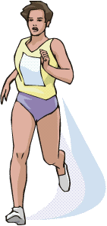  GENERAL
 |  |  |  |  |  |  |  | KM/H | INDIVIDUEL
1 | 1.39.29 | 4 | JENC | YVONA | FOULEE | FV | 67 | 13.4 | 1/35 | 31/336

 | TEMPS | DOSSARD | NOM | PRENOM | CLUB | CAT | ANNEE | MOY | CATEGORIE | GENERAL
 |  |  |  |  |  |  |  | KM/H | RELAIS
1 | 1.47.35 | 1097 | BRAIZAT  GOUJET | PASCAL  HELENE | AMICOURSE  AMICOURSE | H  F | 55  59 | 12.3  12.7 | 10/43  MIXTE | 29/93


